**cs4478 A/B/Y – Master the Mainframe**

**Basic Information**

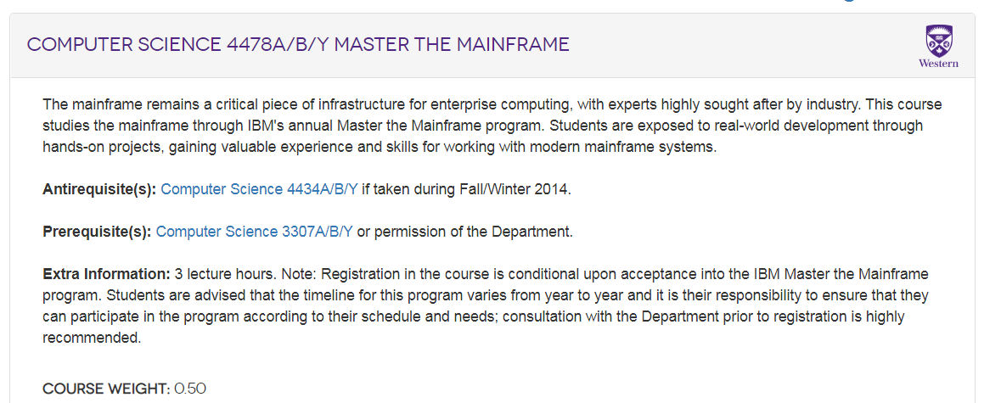

**Course Registration on IBM’s site:**

Once you have enrolled in the cs4478 course at Western, please register yourself using your Western email address at:

<https://www.ibm.com/it-infrastructure/z/education/zxplore>

**Course Coordinator at IBM:**

Shelly Meierarend

Shelly Meierarend <meierar@us.ibm.com>

[NHM – 11/Sep./2023: Awaiting confirmation whether S.M. is still the moderator.]

**Grading Scheme at Western University:**

There are three parts in the course, weighted as follows.

Fundamentals: 10%   
Concepts: 35%   
Advanced: 55%

So, yes, if you complete all the three parts, you deserve a 100% mark. So, go for it!

**Rules to note:**

* Each part is graded by the IBM coordinator as **complete/incomplete**.
  + When either the Concepts or the Advanced part is completed, the student will receive a corresponding “badge” for this. You must download the badge certificates (see instructions on how to do this) and submit the badge to OWL to get a mark. No badge certificate, no mark!
  + For the Fundamentals part, currently, there is no badge. But, you can capture the notification (e.g., via a screenshot) and submit that to OWL.

The following screen-capture is acceptable:

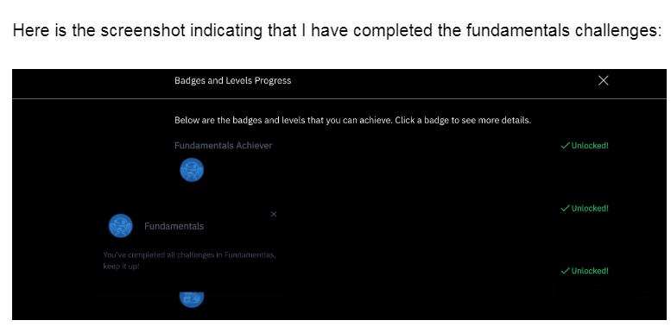

[Please do not send me an email to ask about such issues as the format of your submission files; PDF is acceptable.]

* Under normal system operation, a part without a badge will simply count as “zero” for that part of the course at Western.
* **A student is required to keep his/her logs** (including screenshots) as evidence of the work accomplished **in case there is IBM system failure and data and/or state are not recoverable by the IBM system**. Without such logs, no partial credit will be given for a part.
* Badges and screen capture are to be submitted within the course deadline as instructed by the professor in charge at Western. Corresponding marks will be given, implying a 100% mark for evidence of completing all the three parts.

**Additional benefits of this course:**

* Students can join the IBM Z Student Hub:  [IBM Z Global Student Hub - Group home - IBM Z and LinuxONE Community](https://community.ibm.com/community/user/ibmz-and-linuxone/groups/group-home?CommunityKey=27b746cd-ca36-49bb-a1ad-01e7aec7d9aa) .
* This is a no-cost community that students can join, meet other students around the world who are interested in the same technology.
* Also, IBM is always hosting great knowledge sessions both technical and professional development, for the students.

[NHM: In other words, it’s a lot of fun to learn about enterprise systems, meet like minded people from around the world, get credit, and to make yourself more valuable for the career path ahead.]